M.Sc. Lab Assignment – Introduction to Quantum Gates using Qiskit
Course: Quantum Computing / Quantum Machine Learning
Class: M.Sc.
Lab Duration: 2 Hours
Lab Title: Study and Implementation of Quantum Gates using Qiskit

Objective
To understand basic quantum gates, install the Qiskit library, and implement simple
quantum circuits using Python.

Part 1: Theoretical Study

Pauli-X gate:

Circuit symbol
───[ X ]───

Matrix Representation:
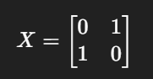

Effect on Basis States
- $X∣0⟩=∣1⟩$
- $X∣1⟩=∣0⟩$
The Pauli-X gate works like a classical NOT gate.
It flips the qubit:
- 0 becomes 1
- 1 becomes 0
That is why it is also called the quantum bit-flip gate.

Pauli-Y gate:

Circuit Symbol :
───[ Y ]───

Matrix Representation:
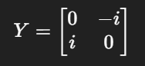
Effect on Basis States
- $Y∣0⟩=i∣1⟩$
- $Y∣1⟩=-i∣0⟩$
The Pauli-Y gate flips the qubit like the X gate, but it also adds a phase factor (i).
So it performs:
- Bit flip
- Plus a phase rotation
It is sometimes called a bit and phase flip gate.
Pauli-Z gate:

Circuit Symbol:
───[ Z ]───

Matrix Representation:
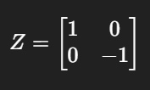

Effect on Basis States
- $Z∣0⟩=∣0⟩$
- $Z∣1⟩=-∣1⟩$
The Pauli-Z gate does not change 0.
But it changes the phase of 1 by adding a negative sign.
So:
- |0⟩ stays same
- |1⟩ becomes −|1⟩
This is called a phase-flip gate.

Hadamard (H) Gate:

Circuit Symbol:
───[ H ]───

Matrix Representation:
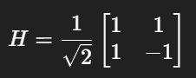

Effect on Basis States
- $H∣0⟩=\frac{∣0⟩+∣1⟩}{\sqrt{2}}$
- $H∣1⟩=\frac{∣0⟩-∣1⟩}{\sqrt{2}}$
The Hadamard gate creates superposition.
It turns:
- |0⟩ into equal mix of |0⟩ and |1⟩
- |1⟩ into equal mix but with a negative phase

CNOT Gate (Controlled-NOT):

Circuit Symbol:
Control ──●──
|
Target ──⊕──

Matrix Representation:
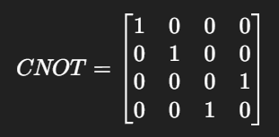

Effect on Basis States
- $∣00⟩→∣00⟩$
- $∣01⟩→∣01⟩$
- $∣10⟩→∣11⟩$
- $∣11⟩→∣10⟩$
The CNOT gate works on two qubits:
- The first qubit is the control
- The second qubit is the target
If control = 1 → flip the target
If control = 0 → do nothing
This gate is very important because it creates entanglement.

Part 2: Installation of Qiskit

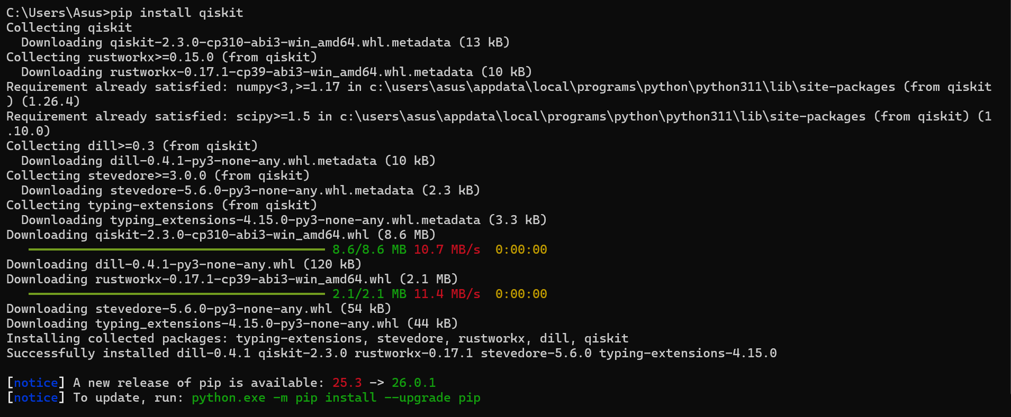

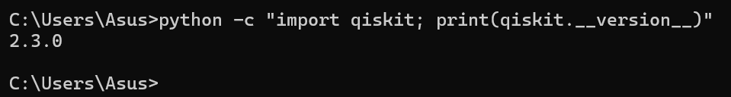

Part 3: Implementation of Quantum Gates
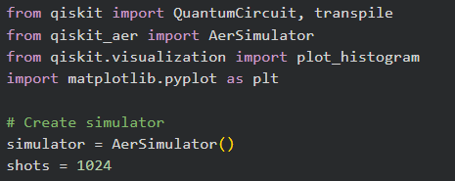
1. Create a single qubit circuit and apply X gate.
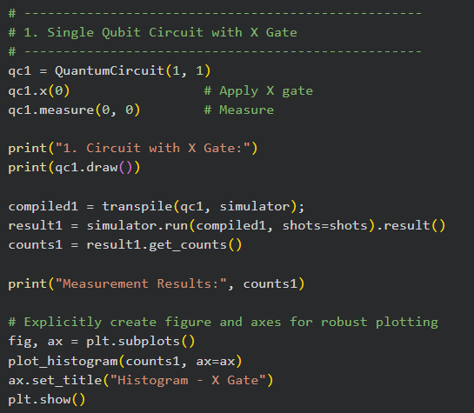

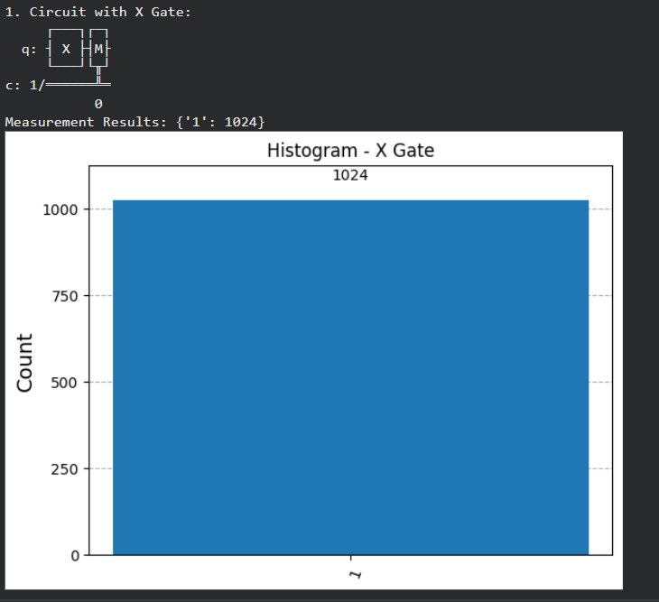

2. Create a single qubit circuit and apply H gate.
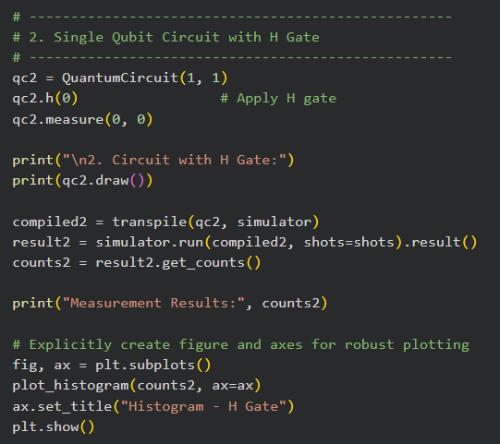
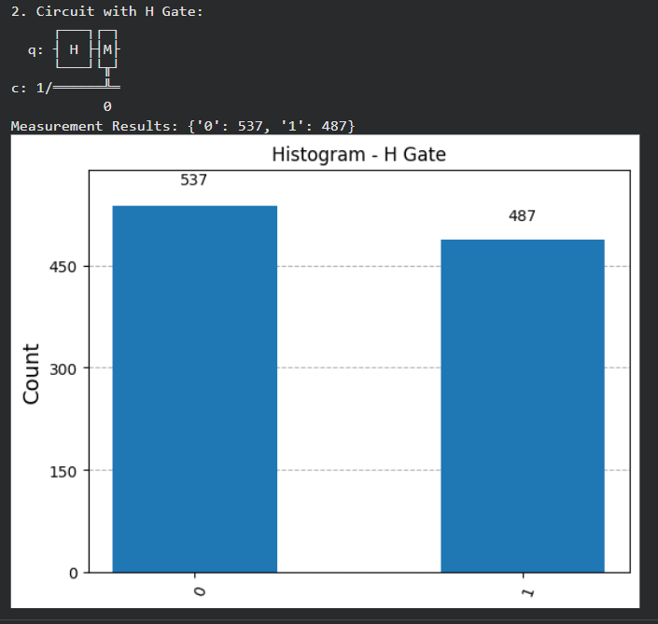

3. Create a two-qubit circuit and apply CNOT gate.
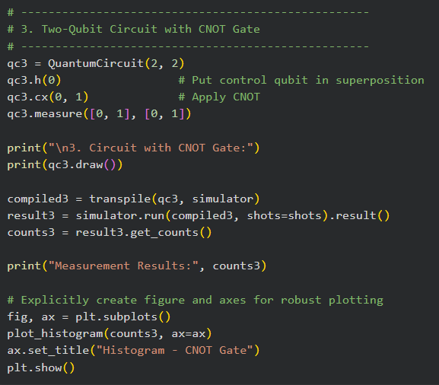
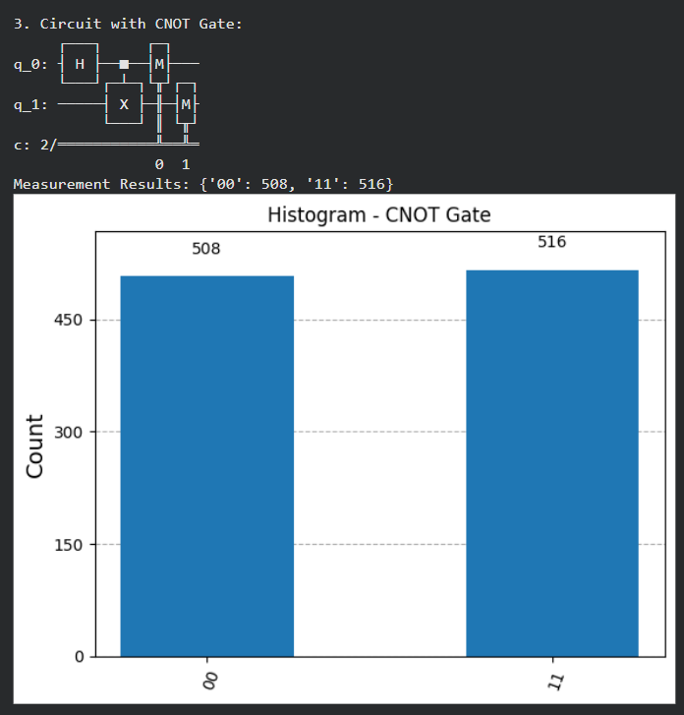

Part 4: Analysis Questions
1. What happens when H gate is applied twice?
Ans- When the Hadamard (H) gate is applied two times in a row, the qubit returns to its original state.
- First H creates superposition.
- Second H cancels that superposition.
- So applying H twice is like doing nothing.
It acts like a reversible operation.

2. What is superposition?
Ans- Superposition is a quantum property where a qubit can exist in a combination of both |0⟩ and |1⟩ at the same time.
A general qubit state:
$$∣ψ⟩=α∣0⟩+β∣1⟩$$
Where:
- $α$and $β$are probability amplitudes
- $∣α∣^{2}+∣β∣^{2}=1$
Unlike a classical bit (which is either 0 or 1),
a qubit can be partly 0 and partly 1 until measured.
When measured:
- It collapses to either 0 or 1.
Superposition is the reason quantum computers can process many possibilities at once.
3. How does CNOT create entanglement?
The CNOT gate entangles two qubits when:
- The control qubit is first put into superposition (usually using H gate).
- Then CNOT is applied.
- Example:

- Step 1:
$$∣00⟩$$
- Step 2 (apply H to first qubit):
$$\frac{∣00⟩+∣10⟩}{\sqrt{2}}$$
- Step 3 (apply CNOT):
$$\frac{∣00⟩+∣11⟩}{\sqrt{2}}$$
- Now the two qubits are entangled.

- Why is this entanglement?
Because:
You cannot describe one qubit independently.
If you measure the first qubit and get 0 → second is also 0.
If you measure the first qubit and get 1 → second is also 1.
Their results are correlated.
4. Why are quantum gates reversible?
Quantum gates are reversible because they are represented by unitary matrices.
A unitary matrix $U$satisfies:
$$U^{†}U=I$$This means:
- Every quantum operation has an inverse.
- No information is destroyed.
- You can always reverse the operation.
In classical computing: Some operations lose information (like AND gate).
In quantum computing:
- Information cannot be lost.
- So every gate must be reversible.
Example:
- X gate is its own inverse.
- H gate is its own inverse.
- CNOT is also reversible.

